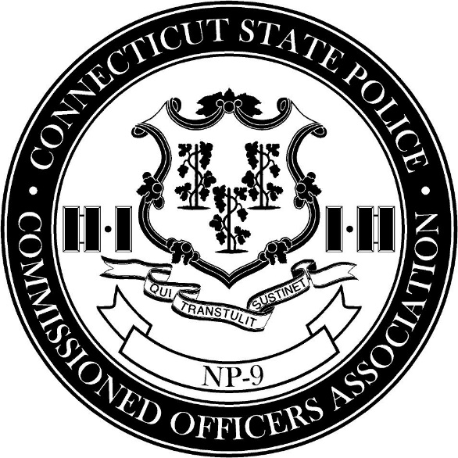

OFFICIAL PRESS RELEASE

On July 25, 2023, the Connecticut State Police Lieutenants and Captains Union conducted a historic unanimous vote of no confidence against Commissioner James C Rovella. Never before have Connecticut State Police commanders conducted a vote of no confidence against any ranking member of the department. We now stand with our brothers and sisters in the Connecticut State Police Union who conducted a vote of no confidence against Commissioner Rovella. This vote solidifies that an overwhelming majority of this agency from the rank of Trooper to Captain has no confidence in Commissioner James C Rovella’s ability to lead this agency going forward.

Over the last five years Commissioner Rovella has continually eroded our confidence in his ability to lead the Connecticut State Police. Since he has taken charge, the agency has never been embroiled in so much controversy. These issues are constant, widespread, and by no means limited to the ticket controversy. Our concerns and expertise as members of command staff are purposefully ignored. Commissioner Rovella has also failed to speak up against misrepresentations in the traffic stop data audit report and communicate clearly to the public the numerous inconsistencies and flaws within the report’s findings.

Notwithstanding, we fully support Colonel Stavros Mellekas, his ability to lead the Connecticut State Police into the future and restore its status as a premier law enforcement agency in the nation.

- NP-9 Commissioned Officers Association

