

SOCIAL EQUITY CONFERENCE PROGRAM
Thank you for attending our event today!
We are happy to have you here and hope you receive plenty of new knowledge and connections.
We ask all our attendees to prioritize respecting the space, our guest speakers, and each other.

11:00 – 11:50 REGISTRATION & CHECK-IN
Meet us at the front entrance of the Artists Collective. We will be waiting for you at a table, ready to provide your name badge, gift bag and any additional instructions. Please have your ticket ready for review upon arrival. Once you have been checked in, feel free to socialize and visit various vendors until lunch begins at 12:00.
11:50 – 12:00 WRAP UP CHECK-IN
12:00 – 12:55 VENDOR SHOWCASE & LUNCH
Venture around the atrium, navigating the various vendor tables and meeting fellow attendees. Make your way into the theatre to grab food and drink. Have a seat at any table in the theatre.
12:55 – 1:00 TRANSITION TO PANEL DISCUSSION
Make your way into the theatre if you have not already done so. Please be seated and prepare to listen in on our first panel discussion. Make sure you are seated at 1:00; we will begin promptly.
1:00 – 1:45 PANEL DISCUSSION: Social Equity and Cannabis Experts
1:45 – 2:00 INTERMISSION
Take a few moments to visit the restroom, stretch, and consider the material we have covered so far. Make sure you have returned to your seat by 2:00. We will begin the next panel discussion promptly.
2:00 – 2:55 PANEL DISCUSSION II:
- Cannabis Collaborations qw
Robert Cornegy: Founder of 610 Collective LLC
- CannaHealth – Medical Marijuana in CT
Kebra Smith-Bolden: RN/CEO/President
- Social Equity Application Process
Lamont Clemons
2:55 – 3:05 TRANSITION TO BREAK-OUT ROOMS
3:05 – 4:05 BREAK-OUT SESSIONS:
      - Legal Representation
      - Cannabis & Banking: Money Matters
      - Technical Assistance & Support for Businesses of Color
4:05 – 4:10 TRANSITION TO OPEN-MINGLING
Make your way back to the atrium where you can network with investors, vendors, speakers and other attendees at your leisure.
4:10 – 5:10 OPEN MINGLING
5:10 – 5:15 TRANSITION TO CLOSING REMARKS
Make your way back into the theatre. Make sure you are seated at 5:15.
5:15 – 6:00 CLOSING REMARKS & WRAP-UP
THANK YOU!


SONSERAE CICERO
CEO | Founder and President for the Society of Human Engagement and Business Alignment



CEO | Founder and President for the Levity Management LLC dba Melanated Marijuana
Sonserae is a business relationship professional with an edge for creating distinctive connections throughout various platforms of HR, diversity, and inclusion. Her background in Human Resources coupled with a graduate’s degree in HR and Labor Relations from the University of New Haven (graduated magna cum laude) and Undergraduate’s degree in Business and legal studies from the University of Hartford (graduated magna cum laude), has shaped her journey in the strategic advancement of workforce diversity, talent development, cultural change management, workplace inclusion, and leadership transformation. She has led diverse work teams across the country focused on improving talent development and transformation for large organizations with portfolios more than 100+ billion dollars.

Amongst her accomplishments, Sonserae works with various re-entry programs in pursuit of fair employment opportunities for individuals who were justice involved with blemished backgrounds. She is a board of trustee member for the Boys and Girls Clubs of Hartford, an advisory board member for Goodwin College Supply Chain and Manufacturing program, as well as the CEO/Founder and President for the Society of Human Engagement and Business Alignment and Levity Management LLC, where she also serves as a business relationship and brand ambassador. Sonserae served as the Chair of the Women of Walgreens Boots Alliance in the US for the supply chain and supported their diversity and development initiatives across the country. In addition to other accomplishments, the NAACP recognized her as one of Connecticut’s 100 most influential individuals of color in 2018.
In March of 2021 Sonserae received an inspiration award for International Women’s Day from the US Women of Walgreens Boots Alliance - Business Resource Group for the work she led with her supply chain field champions across the country. Her aspirations to end period poverty across the country is a constant and endless pursuit. Sonserae is a proud mother of one son. She is also a member of The Links, INC.

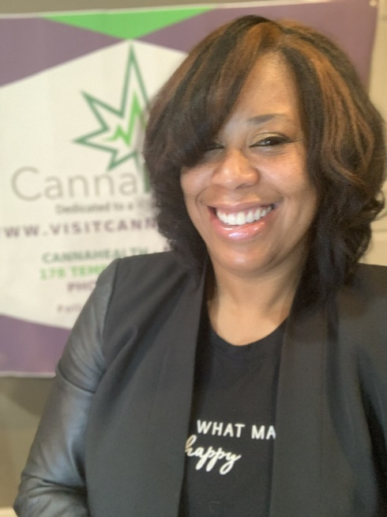
KEBRA SMITH-BOLDEN, RN
CEO | CANNAHEALTH CANNABIS Healthcare Professional &
Cannabis Nursing Expert

CANNAHEALTH

Kebra Smith-Bolden is a true trailblazer, a respected healthcare professional with the vision, purpose and drive to transform the nascent cannabis industry. A registered nurse, Kebra leveraged her medical knowledge and decades of professional experience to create CannaHealthTM, the first and only Connecticut cannabis business owned by an African American. CannaHealthTM is a division of The Healing Choice LLC and HK Smith Enterprises, LLC. Its innovative community-based business model offers disadvantaged communities disproportionately impacted by the war on drugs education about medicinal cannabis, as well as safe and legal access through medical marijuana program evaluations.
An industry pioneer dubbed the “Marijuana Guru in CT,” Smith-Bolden is a medical marijuana (MMJ) expert on topics such as the use of cannabis as a therapy for emotional trauma and chronic disease, as well as dedicating her practice to the expansion and preservation of statewide MMJ programs. In addition to her entrepreneurial ventures, Smith-Bolden is a prominent industry advocate, serving as a member of the National Executive Team for Women Grow, a networking organization that empowers women to become leaders and entrepreneurs in the cannabis industry.
She uses her considerable platform and background in mental health to support disadvantaged communities by studying the use of cannabis in conjunction with therapy for those suffering from complex traumas. The presenting symptoms of people living in high-crime communities are similar to those seen in post combat war veterans suffering from Post-Traumatic Stress Disorder (PTSD). Smith-Bolden CO-Founded and serves as President of CURE, Connecticut United for Reform and Equity, an advocacy group whose purpose is to end the war on our communities, ensure those who have been harmed are made whole, and to create opportunities for our communities to thrive equal to other what other communities are being given.
Other professional affiliations include The Connecticut Coalition to Regulate Marijuana, where she served as Co-Director. Connecticut NORML, where she served as Vice President of their board of directors, Minority Cannabis Business Association, where she served as a Member of the Health Committee, and National Cannabis Industry Association, where she is a member of the Diversity, Equity and Inclusion Committee. Smith-Bolden formerly served as Co-Chief Nursing Officer of the Steering Committee for Huerfano County, Colorado’s Faris Green Campus project to fight opioid addiction with cannabis. Prior to joining the cannabis industry, Smith-Bolden worked as a psychiatric home care nurse, specializing in patients with mental health issues.
She attended Morgan State University, is a graduate of Excelsior College and received a certificate of competency in the cannabis industry from Northeastern Institute of Cannabis. Kebra is currently studying to be an Advanced Practice Registered Nurse at Simmons College in Boston, MA. Kebra is also the recipient of the Nursing Leadership and Innovation award from her professional Honors Nursing Sorority, Sigma Theta Tau. A lifelong Connecticut resident, Smith Bolden is a proud mother and grandmother. She currently resides in New Haven, Connecticut with her family.
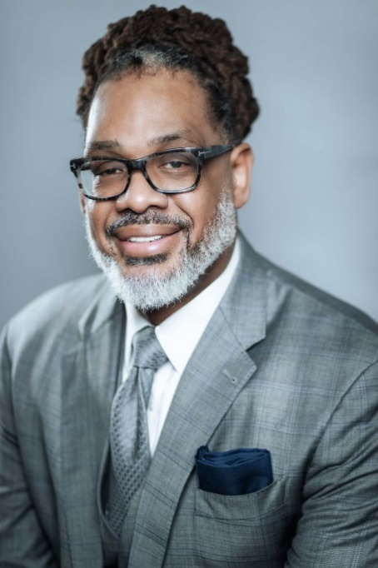
ROBERT E CORNEGY JR.
Principal and Founder | 610 Collective LLC

610 Collective LLC is a full-service MWBE certified consulting firm specializing in Social Equity Cannabis, Affordable Housing and Real Estate development, Equity in Health Care and Small Business, and MWBE Capacity Building. Previously, Robert served two impactful terms in the New York City Council. That 2-term tenure demonstrated his dexterity for leadership and commitment to service. Cornegy served as the Chair of the Council's Committee on Housing and Buildings, Chair of small business, Chair of the Minority- and Women-Owned Business Enterprise Task Force (M/WBEs), and a member of the Budget Negotiating Team. Cornegy was also named Democratic Conference Chair of the New York City Council and was consistently ranked in the top ten percentile for substantive Legislation produced. Roberts Political service is not limited to his time in the New York City Council. Robert has served as Chief of Staff in the New York State Assembly and has managed successful Senatorial bids.
While serving as Democratic District Leader/State Committeeman for the 56th Assembly District and President of the Vanguard Independent Democratic Association Robert was named as a super delegate to President Obama's reelection bid in 2014. As a testament to his keen ability to leverage relationships, Robert, often referred to as a ‘common sense Democrat’ is credited with working across the aisles to create substantive bipartisan policy and legislation. Robert guides all of 610 Collective’s client strategy and interactions and specializes in applying his tactical and strategic expertise to solve complex governmental issues.
His background in legislation and public policy as well as his advanced degree in Organizational Management allow him the ability to always see the people, places, processes, and resources that can offer the most effective solutions to clients' problems. He has extensive experience in developing communications programs and leveraging relationships to advance policy objectives. Robert maintains dynamic relationships on the City, State, and Federal levels. He believes deeply in the value of personal and regular client communication as part of an effective partnership. With determination, compassion, and acute attention to detail, Cornegy has triumphed in many arenas.
From his early career in sports, which included a trip to the final four with St John's University and playing professionally abroad for over a decade in Israel, Turkey, Spain, France, and Columbia, to owning and operating a male mental health facility. He is a pragmatic and energetic leader; from community building to politics, effective healthcare outcomes to real estate development, and everything in between he sees the bigger picture to help his clients tighten their focus, develop sustainable plans, and navigate government successfully. Robert graduated from Mercy College Summa cum laude and from the institution’s Graduate program Magna Cum Laude. Robert remains on the cutting edge of innovative thought by constant engagement with tomorrow's leaders as an instructor at MIT, NYU, and Brooklyn College.
Roberts Accomplishments both personal and professional have not gone unnoticed. A proud father of 7, a member of Omega Psi Phi Fraternity, Inc., and former Guinness book of world record holder for the world's tallest politician at 6 feet 10 inches. It has been said that Robert stands head and shoulders above the rest both figuratively and literally His more recent recognitions include City & State Brooklyn power 100 [#11], M/WBE States Power 50 [#7], Real Estate Power 100, and City & State Fifty over 50.
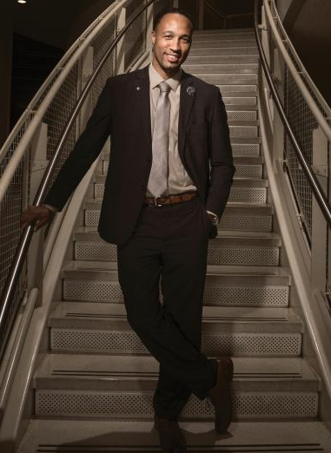
LAMONT CLEMONS
MBA, FE, PMP
S-Cel-O Painting, LLC | Executive Vice President of Strategy and Business Development W/MBE

Lamont Clemons is the owner of First City Provisions Cultivation, Manufacturing and Adult use Retail Dispensary in Holyoke MA. Which is the only majority Black owned, fully vertically integrated company in the State of Massachusetts that has received special permit and host community agreements along with provisional license. Clemons was awarded 1st Place for a Recreational Adult use Cannabis Dispensary in the RFP process in Springfield, MA (4th Largest City in New England).
Lamont’s educational background includes a BS in Electrical Engineering from Virginia State University, MBA with a Concentration in Finance from Clark Atlanta University, and a MS in Project Management from George Washington University. Lamont also has served in the United States Army and was commissioned as an Officer. Lamont received the following certifications: Fundamental in Engineering (FE), Six Sigma Black Belt in Process Improvement, Project Management Professional (PMP)
As the owner of S-Cel-O painting, he is one of the largest painting companies in western Massachusetts that has completed projects such as MGM Springfield Casino, Encore Boston Casino Hotel, Indian Motorcycle Building and has a focus on Large mixed use residential Projects. Lamont has some very strong community ties as he grew up in the area and is very involved on several boards such as Bay Path University, New Valley Bank and Trust, and the YMCA of Greater Springfield. He is also the former President of the McKnight Neighborhood Council, Rotary Club of Springfield, and Pioneer Valley 40 under 40 Recipient in 2016. Amongst Lamont’s accomplishments, he is also the owner of Hillside Dermatology in Agawam, MA.

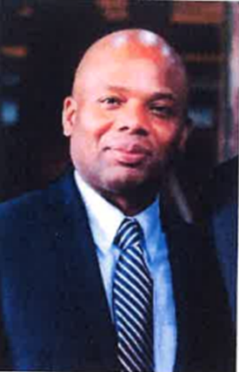
KEVIN HENRY
General Counsel
Since entering private practice, Counsel Henry has handled complex litigation matters in state courts, practiced in criminal defense and commercial and residential real estate transactions. Counsel Henry has practiced in the areas of real estate, commercial, products liability, and insurance litigation, as well as, chaired of the Sports Management Group of an AmLaw 200 Firm. He was a certified player agent for the Women’s National Basketball Players Association as well as a National Football League certified contract advisor.
Counsel Kevin Henry served as vice president of the Hartford Partnership for the Metro Hartford Alliance Chamber of Commerce, where he was responsible for identifying, developing, and implementing economic development strategies for the Office of the Mayor for the City of Hartford and the Hartford Chamber Board of Directors.
In this capacity, he managed the $1 million “Streetscape II” revitalization project and managed all aspects of Hartford Young Professionals and Entrepreneurs (1,000 members) a networking initiative aimed at the retention, recruitment, and optimal utilization of young professionals in the Hartford Region.

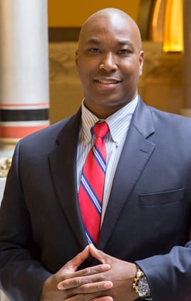
AVERY GADDIS
Senate Minority Leader Appointee | Member of Social Equity Council, as dictated by the adult-use cannabis law, Public Act 21-1
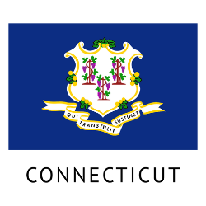
Avery Gaddis has spent more than 20 years advising and assisting the small business community, specializing in entrepreneurship, business growth and development and strategic planning.
Mr. Gaddis has a degree in Political Science from Central Connecticut State University and an MBA from the University of New Haven. He has served on various nonprofit boards and civic organizations, including Hartford VNA Healthcare, Inc., Waterbury Youth Services, Inc. and Hartford Behavioral Health, Inc.
Mr. Gaddis is a former member of the Connecticut Advisory Committee to the U.S. Commission on Civil Rights, current member of Connecticut’s Minority Business Initiative Advisory Board and serves on the Commission on Racial Ethnic Disparity in the Criminal Justice System. He is a current member of the newly formed Social Equity Council.
In 2015, Mr. Gaddis was named as one of the “100 Men of Color.” In both 2015 and 2018, he was designated by the NAACP as one of Connecticut’s “100 Most Influential Blacks.” He was Honorably Discharged from the Army Reserves in 2002 after serving for eight years.

ATTORNEY SHARON A. SKYERS
Sharon Skyers’ practice focuses primarily on Real Estate and Business matters, often serving as outside counsel to corporations and small businesses. With over 25 years of experience, she is a currently a partner with Skyers, Skyers & Harrell, a full service law firm with additional areas of practice that include: criminal law, personal injury, and probate and estates.
Attorney Skyers completed her undergraduate studies at Duke University. She earned a law degree from North Carolina Central University and a Masters in Business Administration from the University of Bridgeport. Attorney Skyers-Jenkins is admitted to practice law in State and Federal Courts

Skyers, Skyers & Harrell, LLC
1087 Broad Street, 3rd Floor
Bridgeport, CT 06604
(203) 334-4800
sajenkins@sshlaws.com

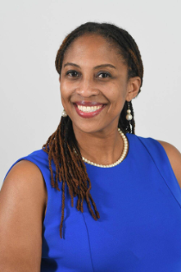SHIRLEY SKYERS-THOMAS
is an attorney, author and advocate with a strong interest in social justice. She has represented a diverse group of legislators, children, youth, parents and educational organizations, in civil and criminal matters. Professionally, she works with the State of CT and is associated with the firm, Skyers, Skyers & Harrell, LLC. As a legal representative, she works on varying aspects that move legislation and public policy forward with an eye to enhancing sustainable and equitable law and policies. Additionally, she is a member of Zeta Phi Beta Sorority Inc. and a member of The Links, Inc.

CEDRIC HAYNES
Associate Vice President, Public Affairs
Cedric brings a wealth of political, policy and procedural experience to Weedmaps as Associate Vice President of Public Affair. Prior, Cedric has led Weedmaps' Emerging Markets team, overseeing legislative, regulatory, coalition building and advocacy efforts in newly-forming marketplaces and the federal government. He also collaborated with the public policy team on research, strategy and relationship building as Director of Public Policy and Partnerships. Cedric's prior experience includes leading the Transportation Security Subcommittee in the US House of Representatives, as well as representing some of America's largest corporations and prominent startups to state and local governments, largely focusing on technology and transportation. When Cedric is not gushing about his hometown (Jackson, Mississippi)... nevermind, he is always gushing over Jackson, Mississippi.

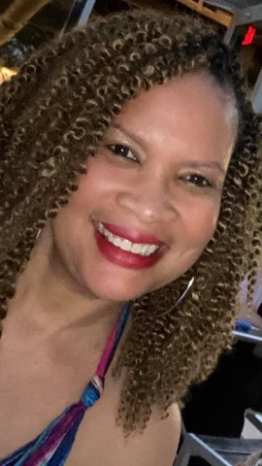SHANNON TODD, MBA
Shannon is an accomplished sales executive, musician and administrator. With experience ranging from education to performance and marketing, Shannon’s unique experience provides her with an unparalleled perspective on interpersonal relationships and business on various levels. She is a classically trained violist and earned a B.A. in Music Performance from Vanderbilt University, from which she developed a discipline for flexible thinking, creativity, and a gusto for giving an outstanding performance, whether onstage or in the boardroom. She also holds an MBA with a Marketing concentration from the University of Phoenix and has over 15 years of experience in sales and marketing. Shannon’s diverse professional background combined with her passion for supporting others has allowed her to excel in various roles and endeavors.
Shannon has been officially recognized for her enterprise both professionally and personally. In 2019, she received an award for outstanding regional sales performance in her current role as a Senior Account Manager with Grainger. While she no longer pursues music professionally, the highlight of her career was sharing the stage with Garth Brooks in his string orchestra. Shannon is also a member of Alpha Kappa Alpha Sorority, Incorporated where she was elected and served on the executive board of her local graduate chapter from 2020-2021. She is a proud mommy to one daughter and one canine.

--
It was character that got us out of bed, commitment that moved us into action, and discipline that enabled us to follow through.
Zig Ziglar

THANK YOU TO ALL OF THE DIGNITARIES, PARTICIPANTS, PARTNERS, MARKETING TEAM AND MOST ALL THE LEVITY MELANATED MARIJUANA TEAM!!!

Maurice Morgan, KJ Griffin, and Frankie Brown you are amazing. We couldn’t have done this without you!!!

